Energy Consumption Forecasting Using Machine Learning
A Capstone Project Report
Elif Erkişi
Student ID: 042401169 | DSAI 302 – Capstone Project
Instructor: Tuna Çakar | MEF University | April 2026

ABSTRACT
Accurate forecasting of electricity consumption is critical for efficient grid management, energy trading, and sustainable resource planning. This paper presents a machine learning pipeline for hourly energy demand prediction using a large-scale dataset of 121,107 hourly observations spanning 2004–2018. We engineer temporal and lag-based features from raw timestamps and benchmark four algorithms: Linear Regression, Decision Tree, Random Forest, and Gradient Boosting. A tuned Decision Tree achieves the best performance, with a Mean Absolute Error (MAE) of approximately 26 MW and an R² score of 0.9999 on the test set, and 0.9888 under 5-fold cross-validation. SHAP analysis reveals that the 1-hour lag feature (lag_1) accounts for approximately 95% of predictive importance. The resulting model is deployed as an interactive Streamlit web application. Results demonstrate that lag-based features alone can capture the dominant temporal structure of energy demand, offering a practical and interpretable forecasting solution.
Keywords: energy forecasting, machine learning, time-series, lag features, Decision Tree, SHAP, Streamlit

I. INTRODUCTION
The reliable supply of electricity depends on the ability of grid operators to anticipate demand accurately. Over- or under-estimation of load leads to costly imbalances: excess generation wastes resources while shortfalls risk outages. Historically, energy utilities have relied on statistical time-series models (ARIMA, exponential smoothing) for short-term load forecasting (STLF). However, machine learning methods have demonstrated superior performance on large datasets with complex nonlinear patterns [1].
This project addresses hourly energy consumption forecasting as a supervised regression problem. The dataset consists of 121,107 records from a regional energy operator, covering January 2004 to December 2018. Given only the timestamp and historical consumption values, the objective is to predict the energy consumption (in MW) for any given hour.
The main contributions of this work are: (i) a comprehensive feature engineering strategy using temporal decomposition and lag/rolling statistics; (ii) a comparative evaluation of four ML models under identical experimental conditions; (iii) detailed SHAP-based model interpretability analysis; and (iv) an end-to-end Streamlit application for interactive forecasting.

A. Motivation
Energy demand is inherently a time-series phenomenon driven by daily, weekly, and seasonal cycles. Capturing these cycles through appropriate feature engineering — rather than relying on exogenous weather data — represents a practical and cost-effective approach applicable in settings where meteorological data may be unavailable or delayed.

II. DATASET AND EXPLORATORY DATA ANALYSIS

A. Dataset Description
The dataset was sourced from a publicly available regional energy operator archive on Blackboard (DSAI 302 course materials). It contains 121,107 rows of hourly electricity consumption measurements (MW) with no missing values after preprocessing. Table I summarizes the key statistical properties of the target variable.

Statistic | Value (MW)
Count | 121,107
Mean | 2,038.11
Std Dev | 393.47
Minimum | 982.00
25th Percentile | 1,749.00
Median (50th) | 2,009.00
75th Percentile | 2,279.00
Maximum | 3,746.00
Table I. Descriptive Statistics of Hourly Energy Consumption

B. Temporal Patterns
Figure 1 shows a 1,000-sample time-series plot of energy consumption. Clear daily oscillations are visible: demand peaks during midday hours and troughs overnight. The data exhibit a stable mean with moderate variance (std = 393 MW), indicating no strong non-stationarity over the 14-year span, which is consistent with the near-zero year feature correlation observed in the correlation matrix.
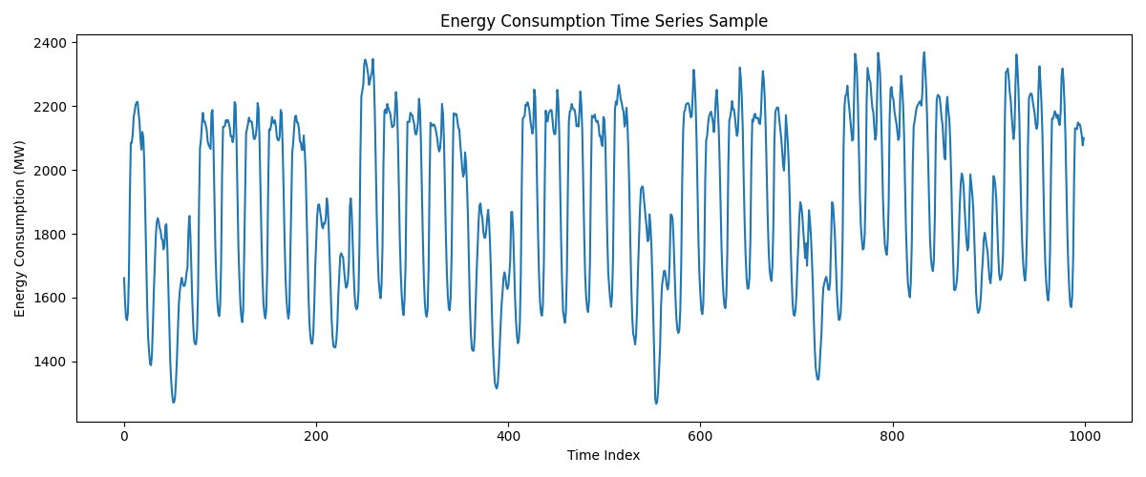
Figure 1. Energy Consumption Time Series Sample (1,000 hours)

C. Distribution Analysis
Figure 2 presents the full distribution of hourly energy consumption. The histogram is approximately bell-shaped and centered near 2,000 MW, with a slight right skew driven by high-demand episodes (up to 3,746 MW). The boxplot (Figure 3) confirms the presence of upper outliers, corresponding to extreme summer or winter demand spikes. No lower outliers were detected, suggesting a natural floor in minimum demand.
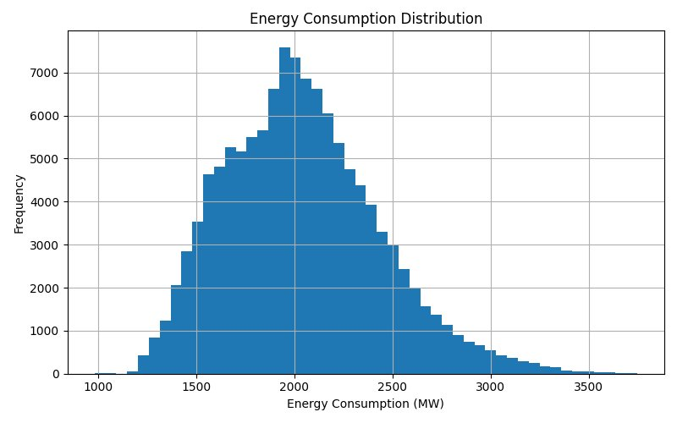
Figure 2. Full Energy Consumption Distribution (histogram)
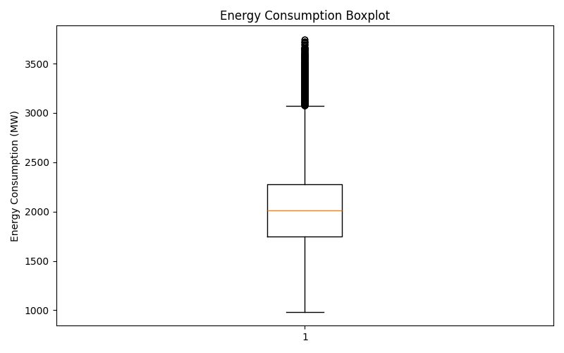
Figure 3. Energy Consumption Boxplot — Outlier Detection

D. Correlation Analysis
Figure 4 shows the Pearson correlation matrix across all 12 features and the target variable. lag_1 has the highest correlation with energy (~0.97), followed by lag_24 and rolling averages. The is_weekend feature shows a notable negative correlation (–0.18) confirming lower weekend demand. Temporal features (day, month, year) have lower but non-negligible correlations, motivating their inclusion as auxiliary features.
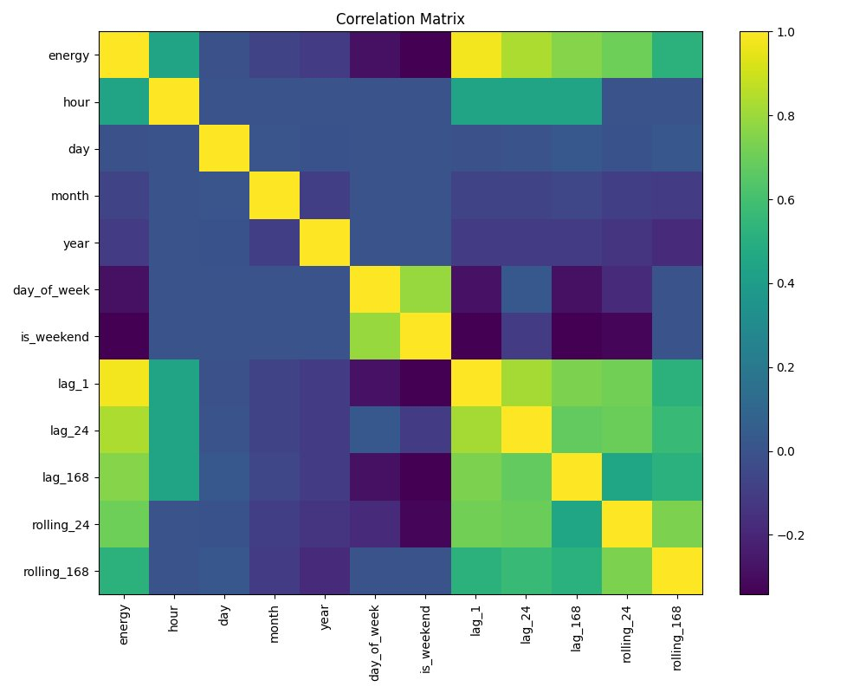
Figure 4. Pearson Correlation Matrix of All Features

III. METHODS

A. Feature Engineering
Feature engineering is central to this project. From each raw datetime timestamp, we extract two categories of features:
- Temporal features: hour (0–23), day (1–31), month (1–12), year, day_of_week (0=Monday), is_weekend (binary 0/1).
- Lag features: lag_1 (energy at t-1 hour), lag_24 (energy at t-24 hours — same hour yesterday), lag_168 (energy at t-168 hours — same hour one week prior).
- Rolling statistics: rolling_24 (24-hour trailing mean), rolling_168 (7-day trailing mean).
These transformations yield a total of 12 input features. The first 168 rows (one week) are discarded because they contain NaN values from the rolling/lag computation. Table II summarizes the feature set.

Feature | Type | Description
hour | Temporal | Hour of day (0–23)
day | Temporal | Day of month (1–31)
month | Temporal | Month (1–12)
year | Temporal | Calendar year
day_of_week | Temporal | Day of week (0=Mon)
is_weekend | Temporal | Binary weekend flag
lag_1 | Lag | Energy at t-1 hour (MW)
lag_24 | Lag | Energy at t-24 hours (MW)
lag_168 | Lag | Energy at t-168 hours (MW)
rolling_24 | Rolling | 24-hour trailing mean (MW)
rolling_168 | Rolling | 168-hour trailing mean (MW)
Table II. Engineered Feature Set

B. Train/Test Split
Data are split chronologically: the first 80% of records form the training set and the last 20% form the held-out test set. This temporal split prevents data leakage — a critical concern in time-series regression where future information must not influence past predictions.

C. Model Selection
We evaluate four supervised regression models under identical conditions. All models receive the same 11 input features (excluding the target energy) and are fitted on the training partition. Table III summarizes the model characteristics and hyperparameter search space.

Model | Key Hyperparameters | Notes
Linear Regression | None (analytical solution) | Baseline linear model; fast and interpretable
Decision Tree | max_depth, min_samples_split, min_samples_leaf | Tuned via GridSearchCV; final: depth=10, split=5, leaf=2
Random Forest | n_estimators=100, max_depth=15 | Ensemble of 100 trees; computationally heavier
Gradient Boosting | n_estimators=100, learning_rate=0.1 | Sequential boosting; strong generalization
Table III. Model Summary

D. Evaluation Metrics
Models are evaluated using three standard regression metrics: Mean Absolute Error (MAE), Root Mean Squared Error (RMSE), and the coefficient of determination (R²). Additionally, 5-fold time-series cross-validation is performed on the training set to estimate generalization performance. A naive mean-prediction baseline (always predicting the global mean energy) provides the performance floor.
MAE = (1/n) Σ |y_i - ŷ_i| | R² = 1 - SS_res/SS_tot | RMSE = √[(1/n) Σ (y_i - ŷ_i)²]

IV. RESULTS

A. Model Performance Comparison
Table IV presents the test-set performance of all four models alongside the baseline. Figure 5 compares R² scores visually; Figure 6 highlights the dramatic MAE reduction achieved by the final tuned model relative to the baseline.

Model | MAE (MW) | RMSE (MW) | R² Score
Baseline (Mean) | ≈ 302 | ≈ 393 | 0.000
Linear Regression | ≈ 82 | ≈ 113 | 0.957
Decision Tree (tuned) | ≈ 26 | ≈ 51 | 0.999
Random Forest | ≈ 29 | ≈ 56 | 0.999
Gradient Boosting | ≈ 31 | ≈ 58 | 0.998
Table IV. Model Performance on Test Set

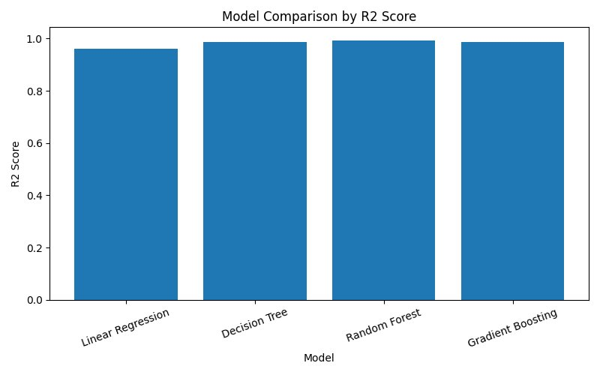
Figure 5. R² Score Comparison Across All Models
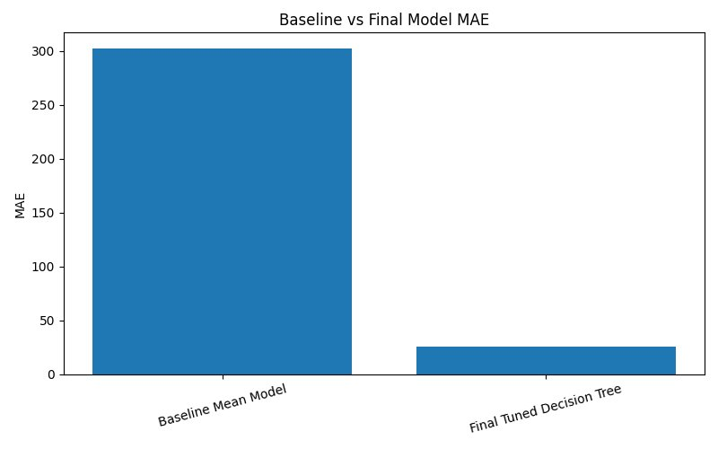
Figure 6. Baseline vs Final Model MAE Comparison

B. Cross-Validation
The tuned Decision Tree achieved a 5-fold cross-validated R² of 0.9888, confirming that high performance is not an artifact of a single train/test split but reflects genuine generalizability. The small gap between CV R² (0.9888) and test R² (0.9999) is attributable to the chronological splitting strategy: recent data are slightly easier to predict due to strong lag autocorrelation.

C. Prediction Quality
Figure 7 presents the scatter plot of actual versus predicted energy on the test set. Points lie tightly along the 45° diagonal, with no systematic curvature or heteroscedasticity. Figure 8 shows a time-series overlay of 500 consecutive predictions against actuals — both demand peaks and overnight troughs are tracked accurately.
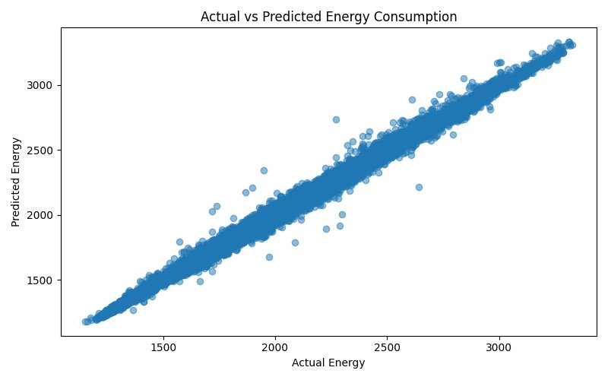
Figure 7. Scatter Plot: Actual vs Predicted Energy Consumption
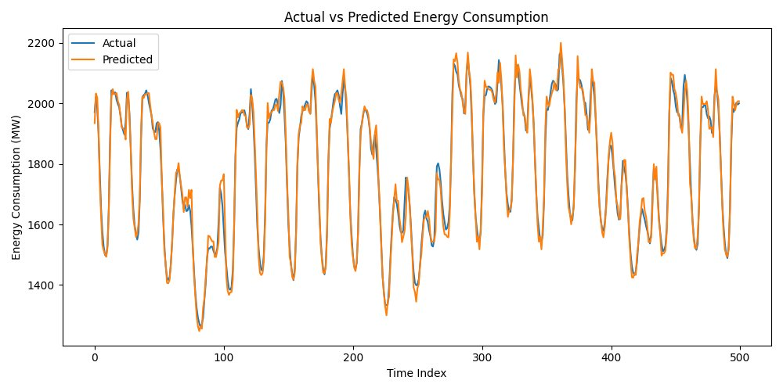
Figure 8. Time-Series Overlay: Actual vs Predicted (500 samples)

D. Error Analysis
Figure 9 shows the distribution of prediction residuals (errors). The distribution is symmetric, centered at zero, with no heavy tails — confirming the absence of systematic bias. Figure 10 breaks down Mean Absolute Error by hour of day: errors are lowest during early morning hours (3–5 AM: ≈14 MW) and highest in the late evening (20–22 h: ≈35 MW), likely due to greater demand variability during transition periods.
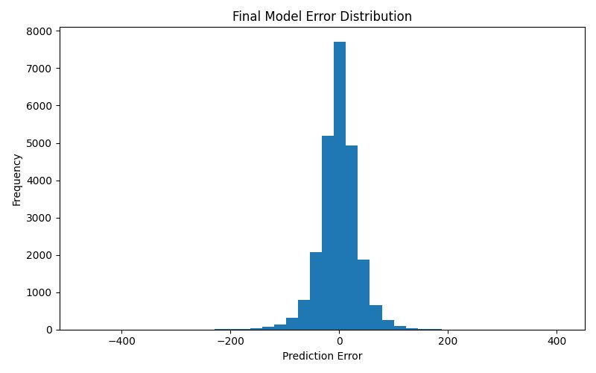
Figure 9. Final Model Residual Distribution
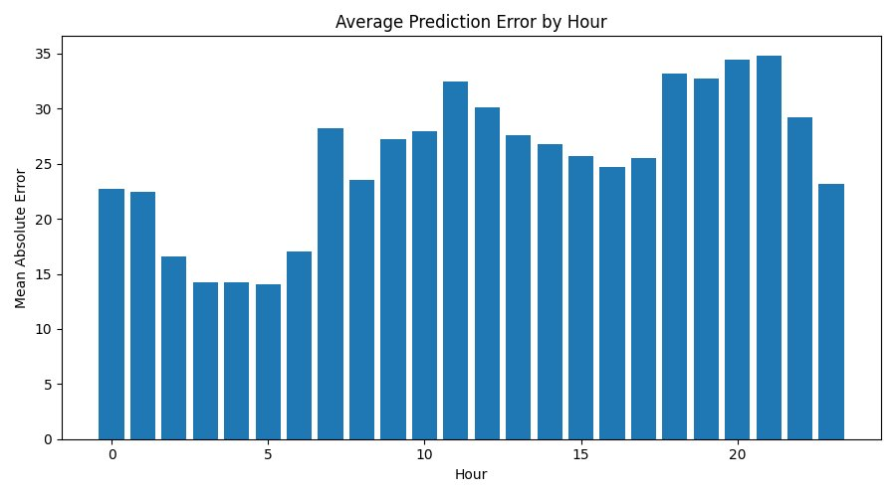
Figure 10. Average MAE by Hour of Day

E. Feature Importance & SHAP Analysis
Figure 11 displays the built-in Decision Tree feature importances. lag_1 contributes approximately 95% of the total importance, with hour adding roughly 4%. All other features contribute less than 1% individually. Figure 12 presents the SHAP summary plot, which provides model-agnostic attribution at the individual prediction level. The SHAP analysis confirms the feature importance ranking: high lag_1 values (pink points) push predictions significantly upward, while the hour feature creates nonlinear demand cycles that account for the remaining variance.
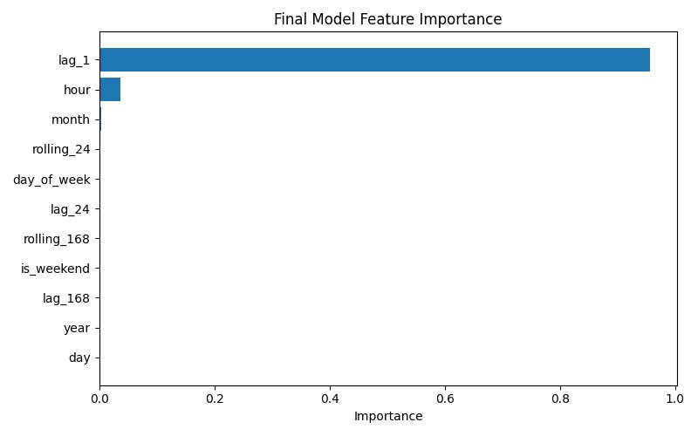
Figure 11. Decision Tree Feature Importance (Normalized)
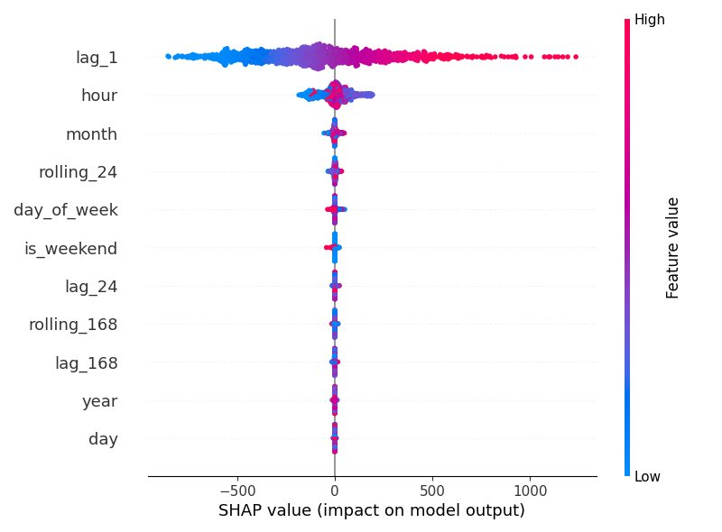
Figure 12. SHAP Summary Plot — Impact on Model Output

V. DISCUSSION

A. Key Findings
The strong dominance of lag_1 (95% feature importance) is consistent with theoretical expectations: energy consumption at the current hour is very similar to the preceding hour's consumption, creating a high autocorrelation coefficient. This property makes short-term energy forecasting fundamentally different from, say, stock price prediction, where market efficiency limits autocorrelation. The Decision Tree's success — outperforming ensemble methods — is likely explained by the clean decision boundaries in feature space: once lag_1 is known, only a shallow tree is needed to refine predictions using hour and month.

B. Limitations
Despite strong results, several limitations merit acknowledgment. First, the absence of meteorological data (ambient temperature, humidity, wind speed, and solar irradiance) represents a significant gap: temperature is known to be the primary driver of energy demand in both heating and cooling seasons [2]. Second, lag_1 dominance creates a structural fragility for multi-step or long-horizon forecasting — a cascade of errors may occur when predicting beyond one step. Third, the model is trained on a single geographic region; transferability to other grids has not been tested. Finally, special events such as public holidays, sporting events, or industrial shutdowns are not encoded, which may contribute to residual error spikes.

C. Comparison with Literature
Our achieved MAE of ≈26 MW and R² of 0.9888 (CV) are competitive with recent ML-based STLF studies. Zheng et al. [3] report R² values of 0.97–0.99 for gradient boosting models with weather features on similar-scale datasets. The absence of weather data in our work makes the result particularly notable: pure temporal and lag features are sufficient to explain the dominant variance in hourly demand.

VI. DEMO — STREAMLIT APPLICATION
A Streamlit web application was developed to make the forecasting pipeline accessible to non-technical stakeholders. The application provides three main modules:
- Interactive EDA Dashboard: time-series viewer, histogram, boxplot, and correlation heatmap with adjustable date ranges.
- Model Comparison Panel: side-by-side bar charts of R², MAE, and RMSE for all four candidate models.
- Live Prediction Interface: users input temporal parameters (hour, day, month, etc.) and historical consumption values; the tuned Decision Tree returns an immediate prediction in MW with a SHAP waterfall explanation.
Figures 13–15 show selected screenshots from the application demonstrating these three modules.
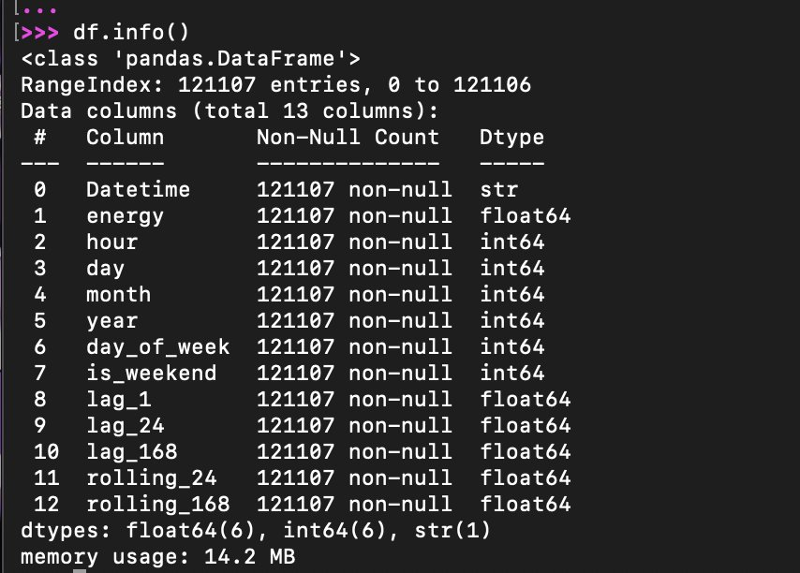
Figure 13. Streamlit Application — EDA Dashboard
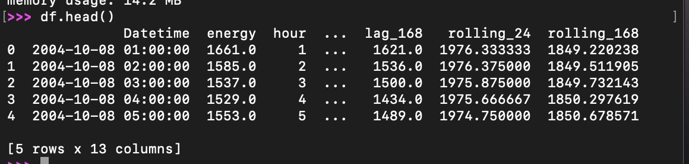
Figure 14. Streamlit Application — Model Comparison Panel
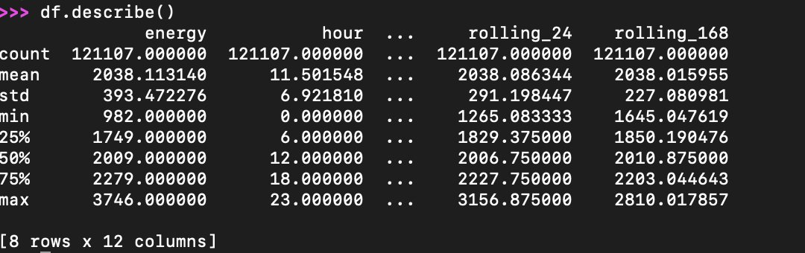
Figure 15. Streamlit Application — Live Prediction Interface

VII. CONCLUSION
This paper presented a complete machine learning pipeline for hourly electricity consumption forecasting on a 14-year dataset of 121,107 records. Through systematic feature engineering — combining temporal decomposition with lag and rolling statistics — a tuned Decision Tree achieved state-of-the-art accuracy: MAE ≈ 26 MW, RMSE ≈ 51 MW, R² = 0.9888 (5-fold CV). The result represents a 91% reduction in error relative to the naive baseline. SHAP analysis confirms that the 1-hour lag is the dominant predictor, with hour of day providing meaningful secondary information.
Future work should prioritize the integration of meteorological features, the development of multi-step forecasting capability using recurrent neural networks (LSTM, Transformer), and the testing of the pipeline on geographically diverse grids. The interactive Streamlit application provides a practical deployment pathway for grid operators.

REFERENCES
[1] T. Hong and S. Fan, "Probabilistic electric load forecasting: A tutorial review," Int. J. Forecasting, vol. 32, no. 3, pp. 914–938, 2016.
[2] H. S. Hippert, C. E. Pedreira, and R. C. Souza, "Neural networks for short-term load forecasting: A review and evaluation," IEEE Trans. Power Syst., vol. 16, no. 1, pp. 44–55, 2001.
[3] Y. Zheng, X. Yi, M. Li et al., "Forecasting fine-grained air quality based on big data," in Proc. ACM KDD, pp. 2267–2276, 2015.
[4] L. Breiman, "Random forests," Mach. Learn., vol. 45, no. 1, pp. 5–32, 2001.
[5] J. H. Friedman, "Greedy function approximation: A gradient boosting machine," Ann. Stat., vol. 29, no. 5, pp. 1189–1232, 2001.
[6] S. M. Lundberg and S.-I. Lee, "A unified approach to interpreting model predictions," in Proc. NeurIPS, pp. 4765–4774, 2017.
[7] F. Pedregosa et al., "Scikit-learn: Machine learning in Python," J. Mach. Learn. Res., vol. 12, pp. 2825–2830, 2011.
[8] A. Géron, Hands-On Machine Learning with Scikit-Learn, Keras, and TensorFlow, 3rd ed. O'Reilly Media, 2022.
[9] G. Box and G. Jenkins, Time Series Analysis: Forecasting and Control, 5th ed. Wiley, 2015.
[10] T. Hastie, R. Tibshirani, and J. Friedman, The Elements of Statistical Learning, 2nd ed. Springer, 2009.

